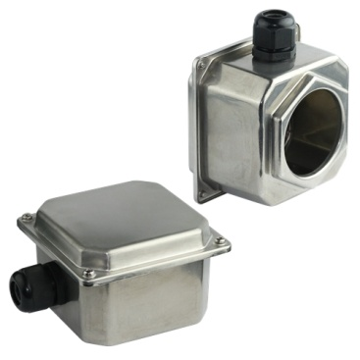

**Type Y3SC**

**Big immersion heater enclosure, with flat cover and stamped hexagon, for big immersion heaters**

Deep drawn enclosure for moderately corrosive media, in stainless steel AISI 304 or AISI 316. These enclosures provide a good compromise between impact resistance, weather resistance and chemicals. They are non-flammable and have a maximum IP69K degree of ingress protection.Size (mm): Dia. 125 x 125 x 85. Volume (cm3): 1000.